# Git Assignment-1

**1. Based on what you have learnt in the class, do the following steps:**

**a. Create a new folder**

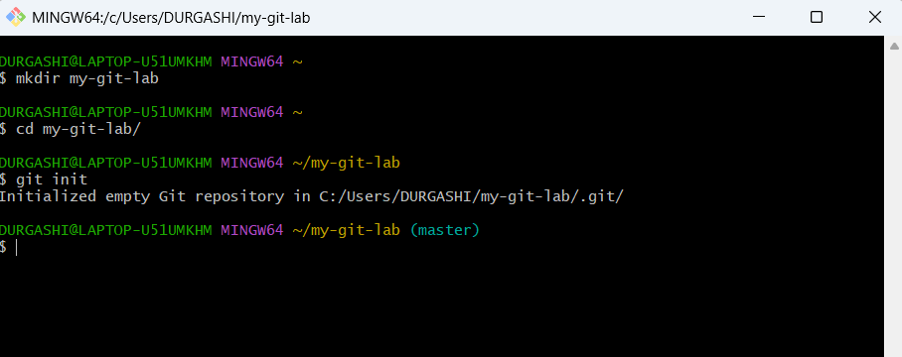

**b. Put the following files in the folder**

**● Code.txt**

**● Log.txt**

**● Output.txt**

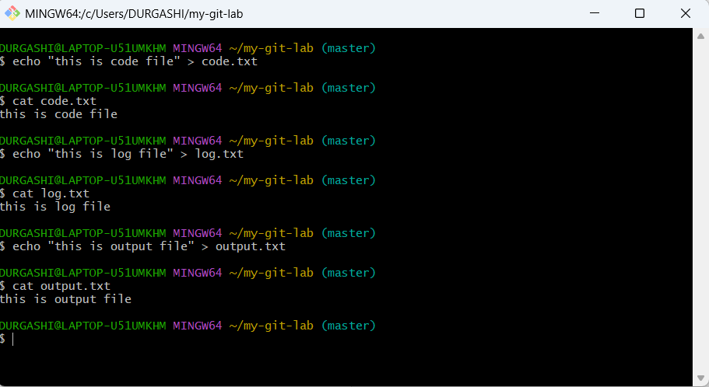

**c. Stage the Code.txt and Output.txt files**

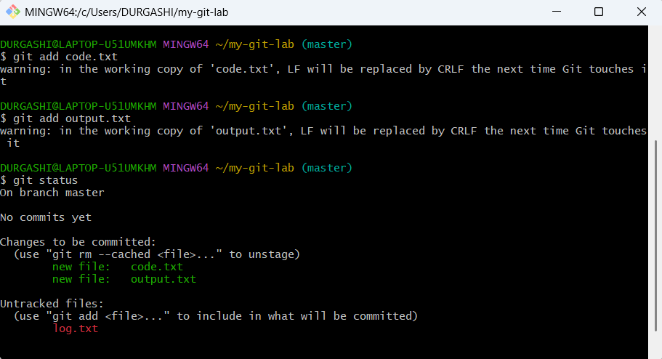

**d. Commit them**

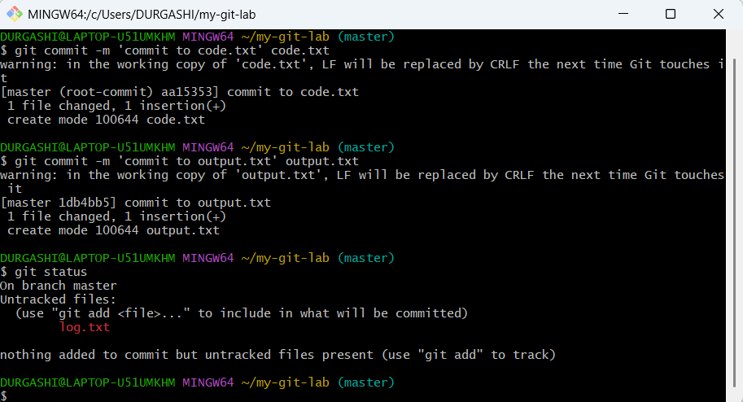

**e. And finally push them to GitHub**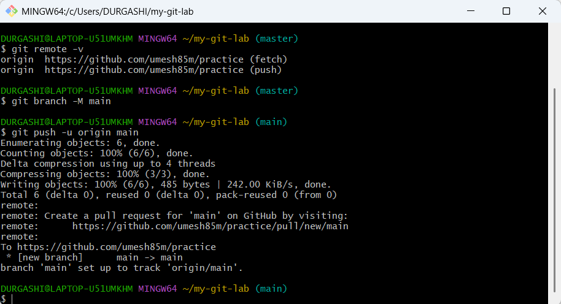

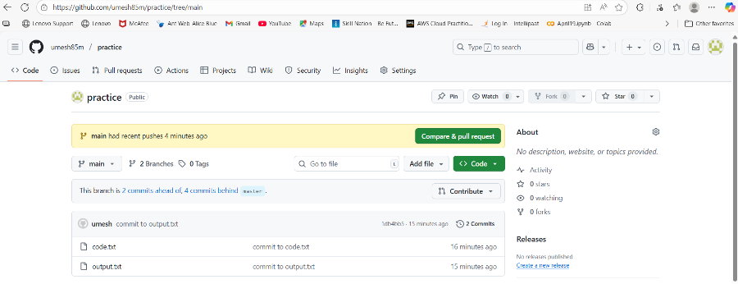

**2. Please share the commands for the above points**

mkdir my-git-lab

cd my-git-lab/

git init

echo "this is code file" > code.txt

echo "this is log file" > log.txt

echo "this is output file" > output.txt

git add code.txt

git add output.txt

git status

git commit -m "commit code.txt and output.txt"

git status

git remote add origin <https://github.com/umesh85m/practice>

git remote -v

git branch -M main

git push -u origin main